Supplementary material

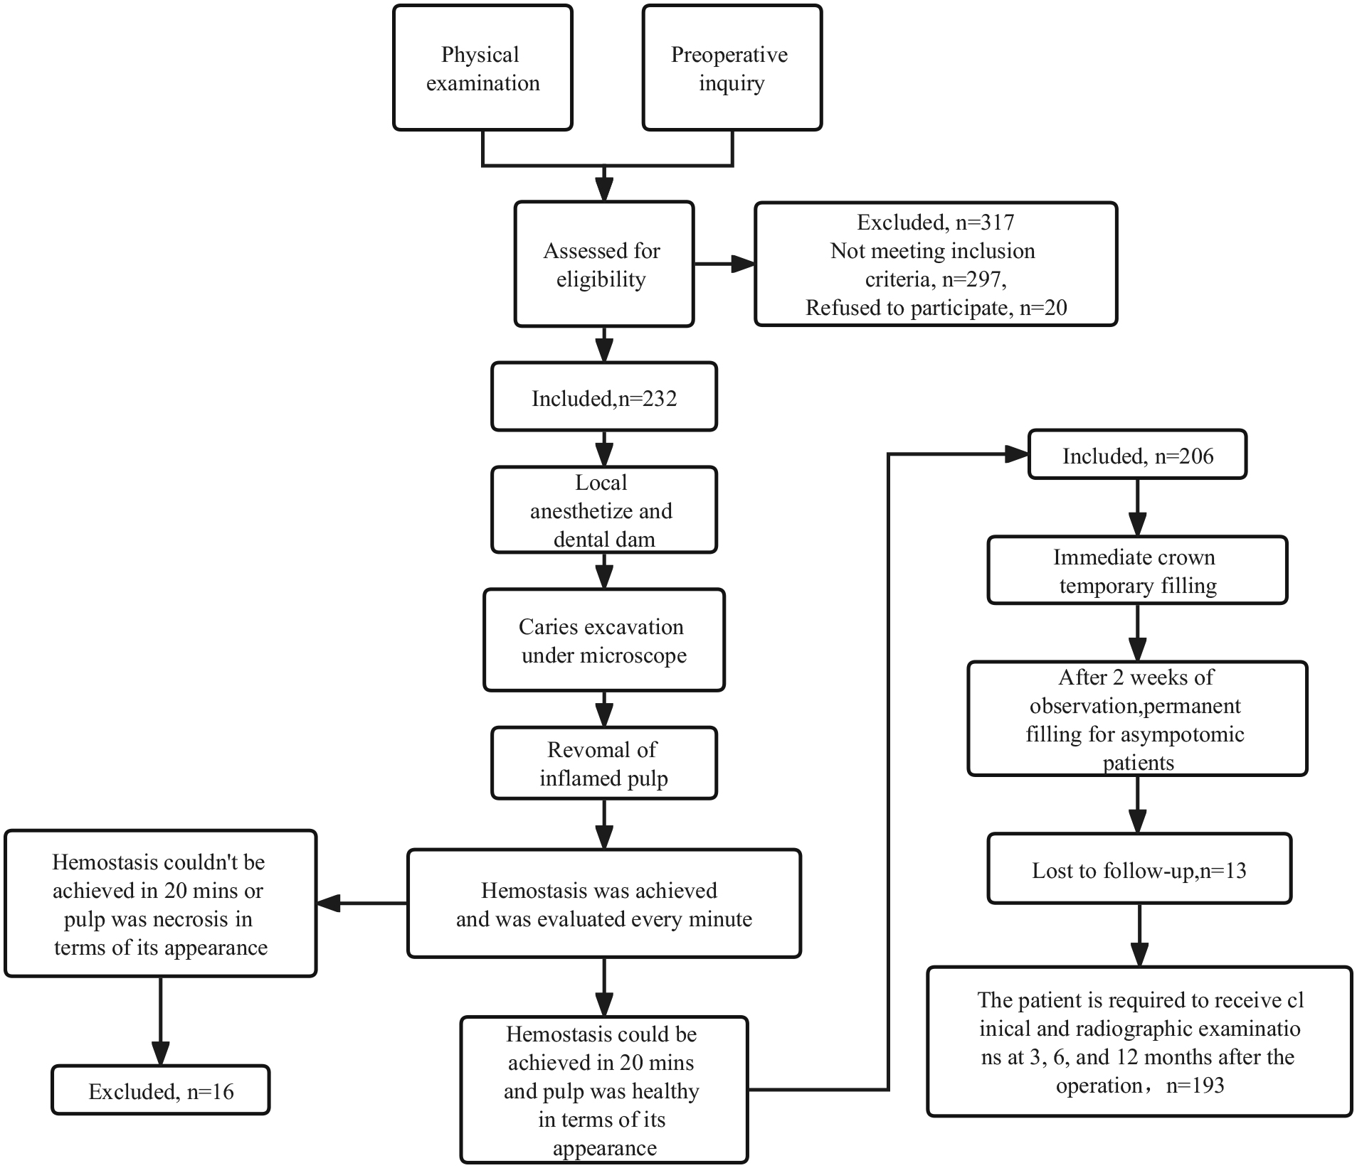
Supplementary Fig. 1. Flow diagram of the present study.

